Step 1: launch MySQL Workbench

Step 2 : Create the Connection

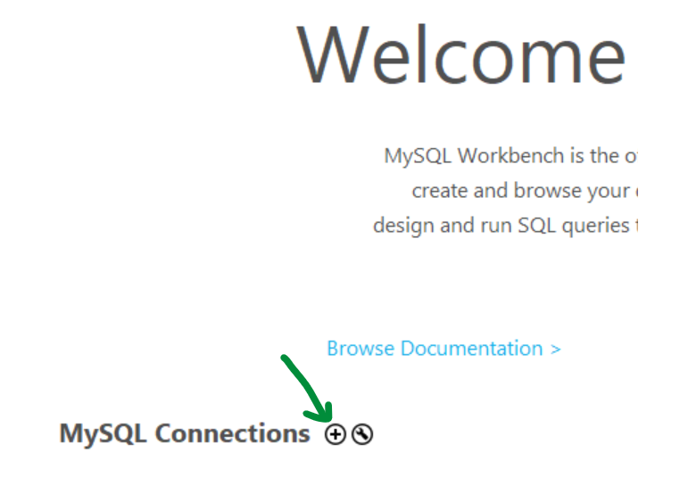

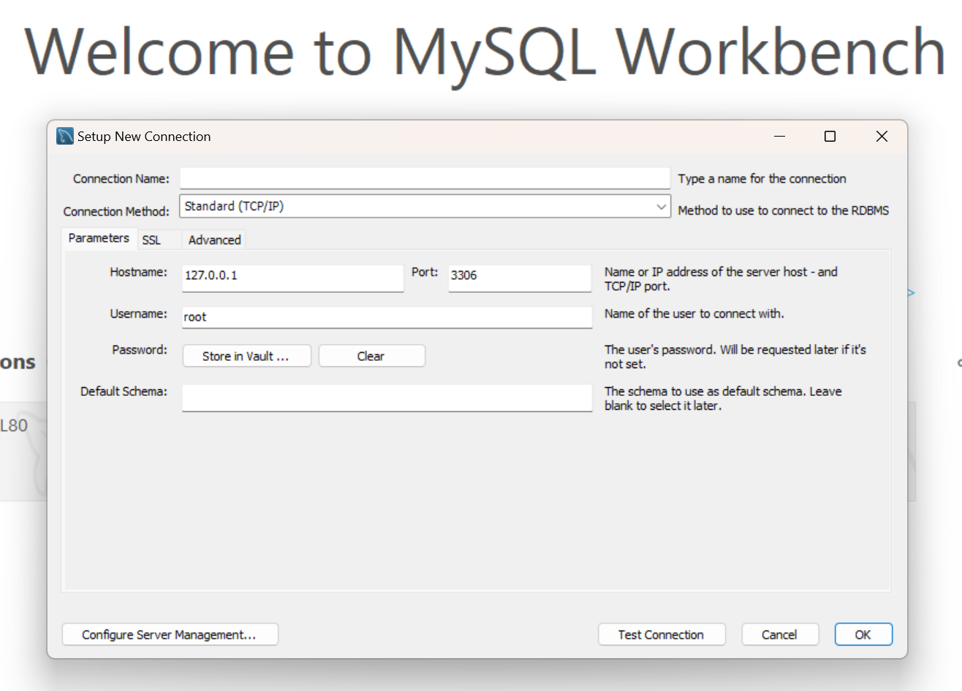

Step 3: we are ready to get started with Coding

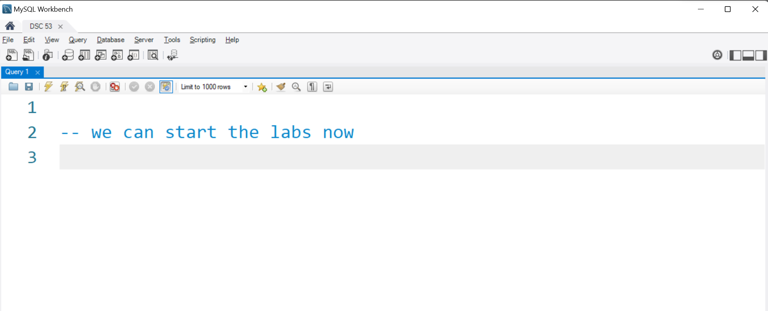

Step 4: to Do the Labs we will Import a Dataset :

In the next step i ll share the steps to import the dataset

Step 4.1 : Download the dataset from the url below , the file name is world.sql

<https://drive.google.com/file/d/0B5FZLecDIxk8Z29XZVFzOFNPb0k/view?usp=sharing&resourcekey=0-xTDZQk7XZXljg1CnjfDrug>

Step 4.2 :

Go to File Menu and click on Open SQL Script

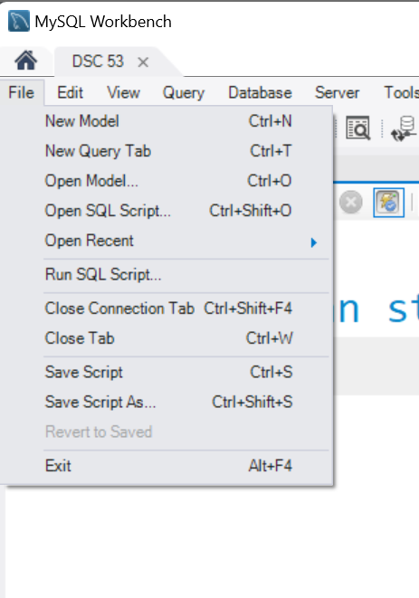

Step 4.3 : clicking on menu opens a dialog , here brows the file world.sql and click Open.

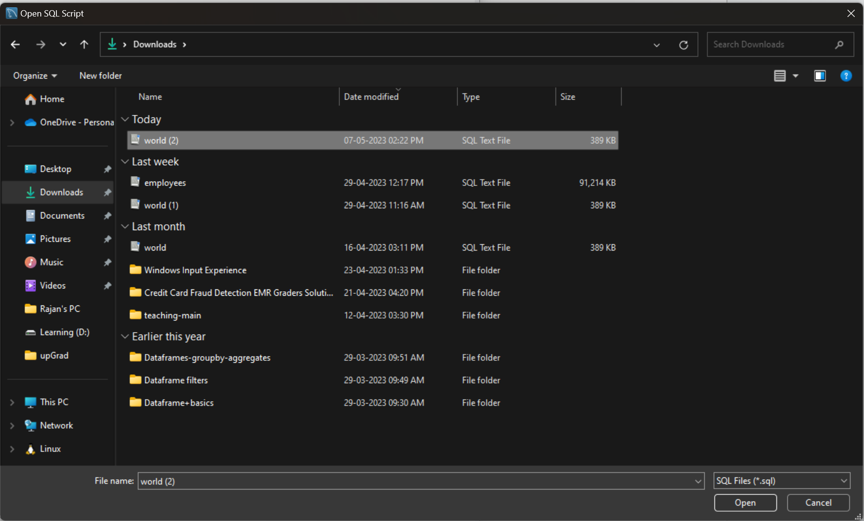

Step 4.4 :

Click on Ok Button

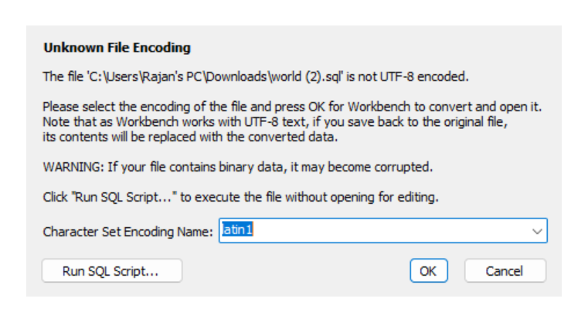

Step 4.5 :

You will that the previous steps open the world.sql file in Workbench , now we will run the script

To run the script click on Flash Icon shown below

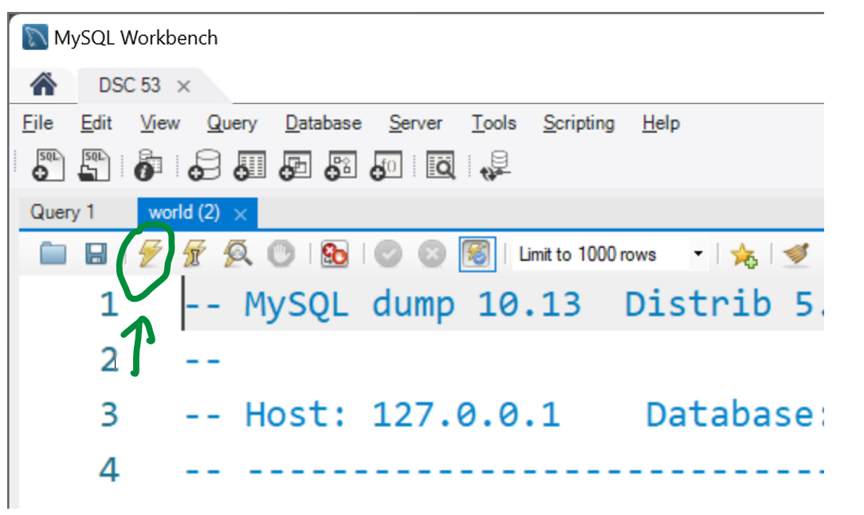

Note: if your flash button is disabled it means u have not created connection with server.

Create the connection first and repeat the steps from 4.1 again.

.

Step 4.6 : green ticks at the bottom is clear confirmation that you have successfully imported the

Script.

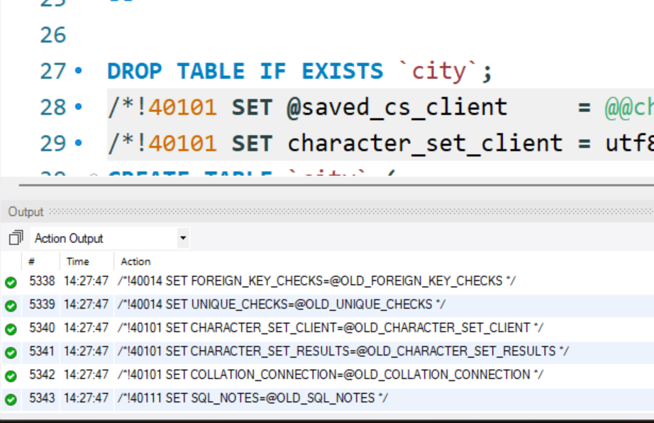

We are done with importing script.

Step 5: Create a new Query Tab to do the Labs

Or you can switch to previously created query tab as shown below

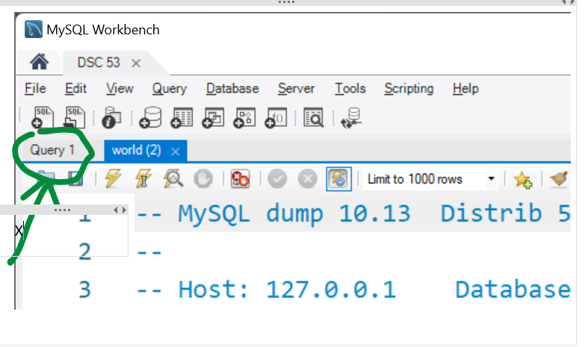

Step 6:

**-- Please note : the script that we just RAN created a Database in our System**

**-- named : world**

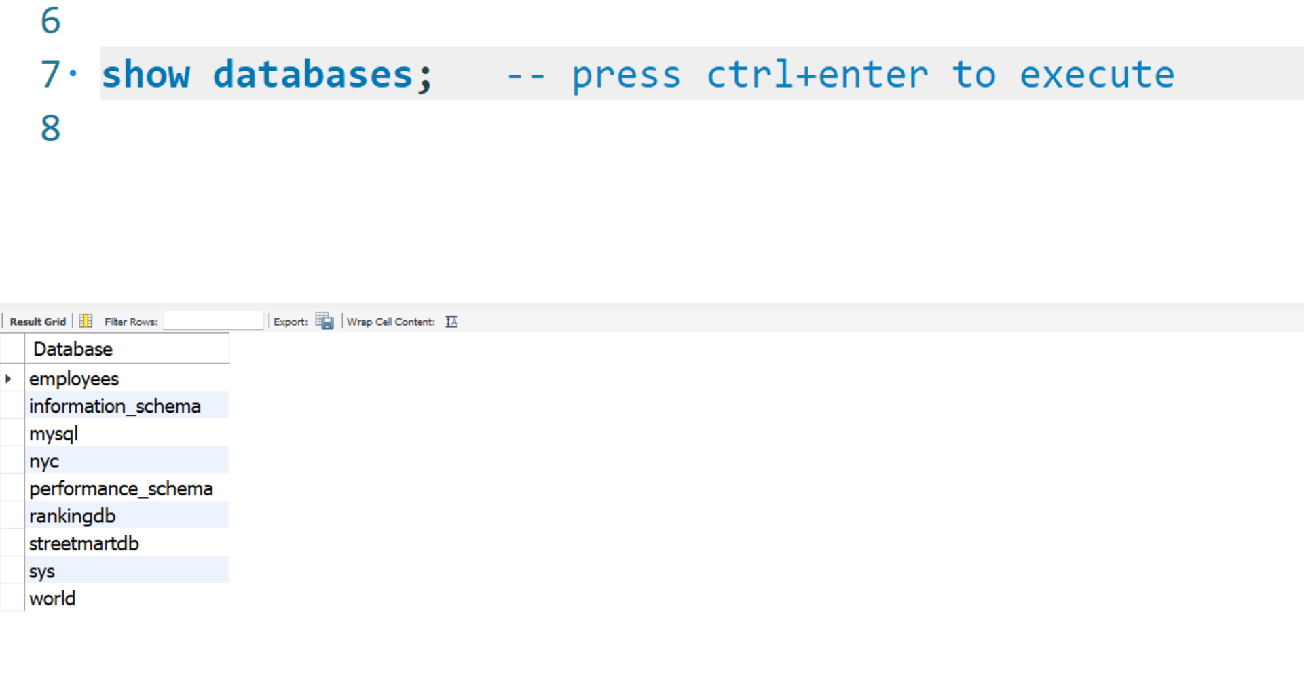

Step 7: select the database using use command;

**(note: beginners tend to forget this step )**

use world;



-- let us see what all tables it has (world database)

show tables;

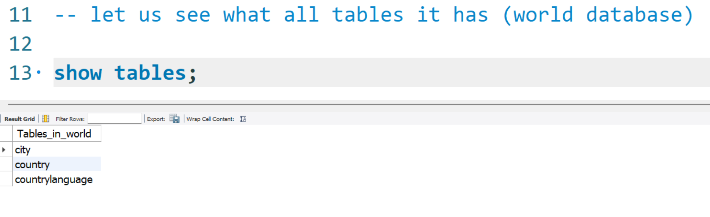

All the cities in world

All countries in world

All languages spoken in world.

Step 8 : let us study the data

select * from city;

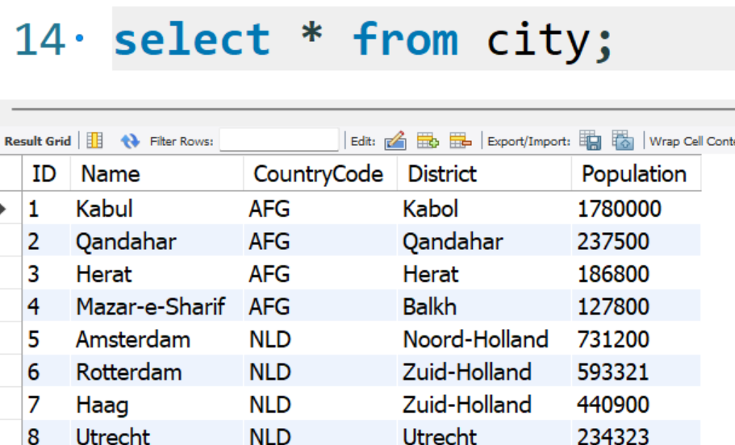

Select * from country;

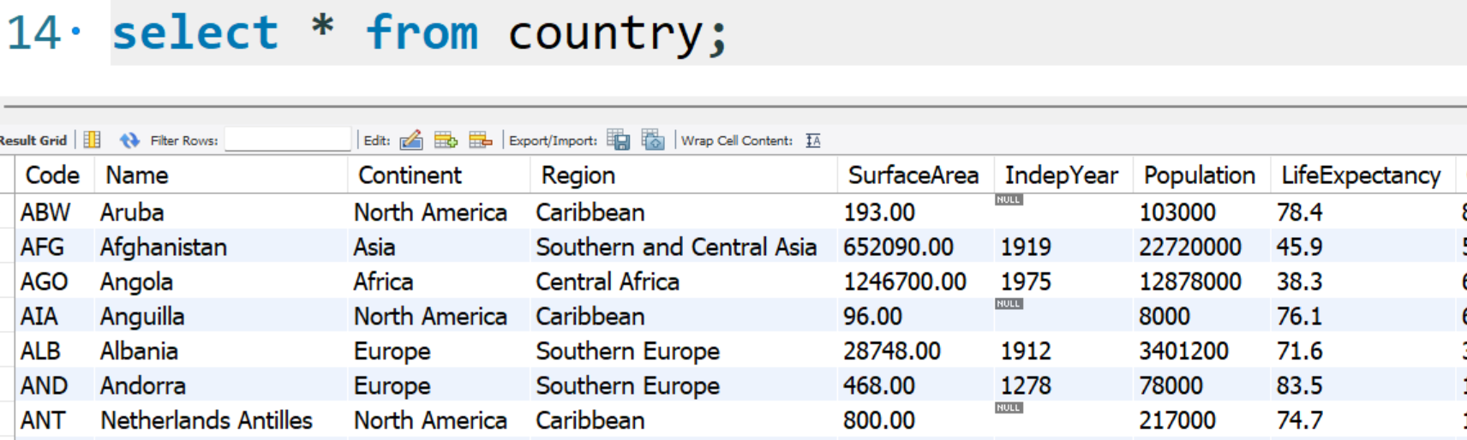

Select * from countrylanguage;

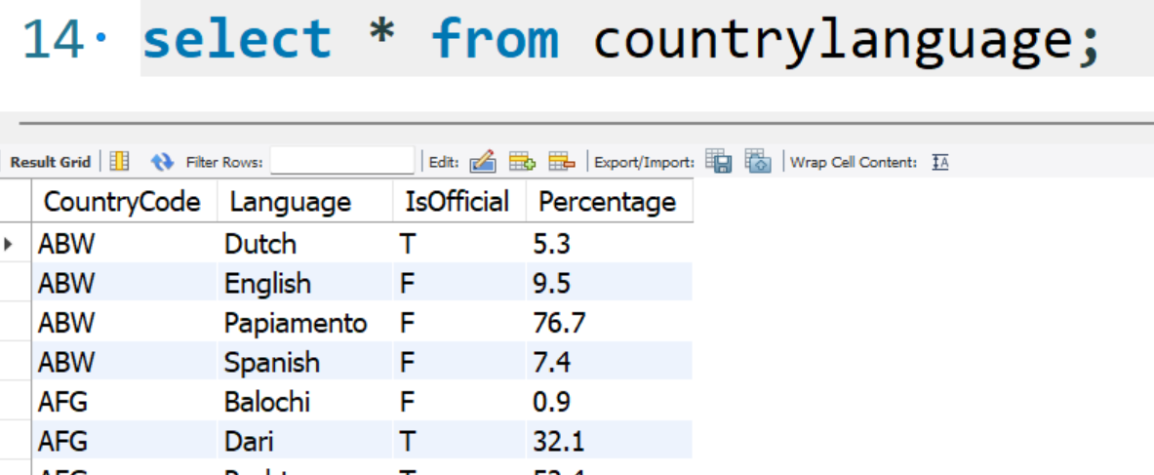

-- objective: display table in Sql

-- syntax: select * from <tableName>

select * from city;

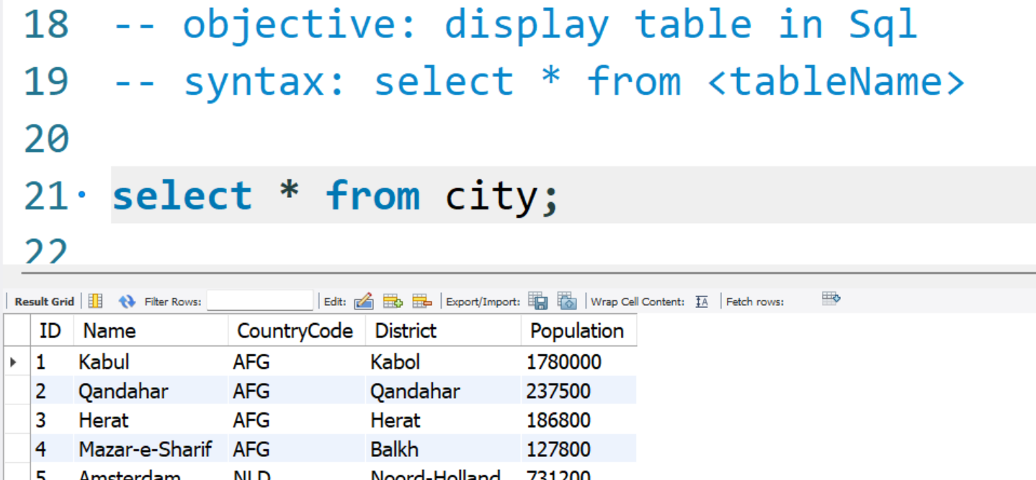

-- objective: can we select choice of columns instead of all : yes

select name,district,population from city;

-- note: * means fetch all columns , if u wish to fetch choice of columns,

-- skip * and specify choice of columns separated by ,

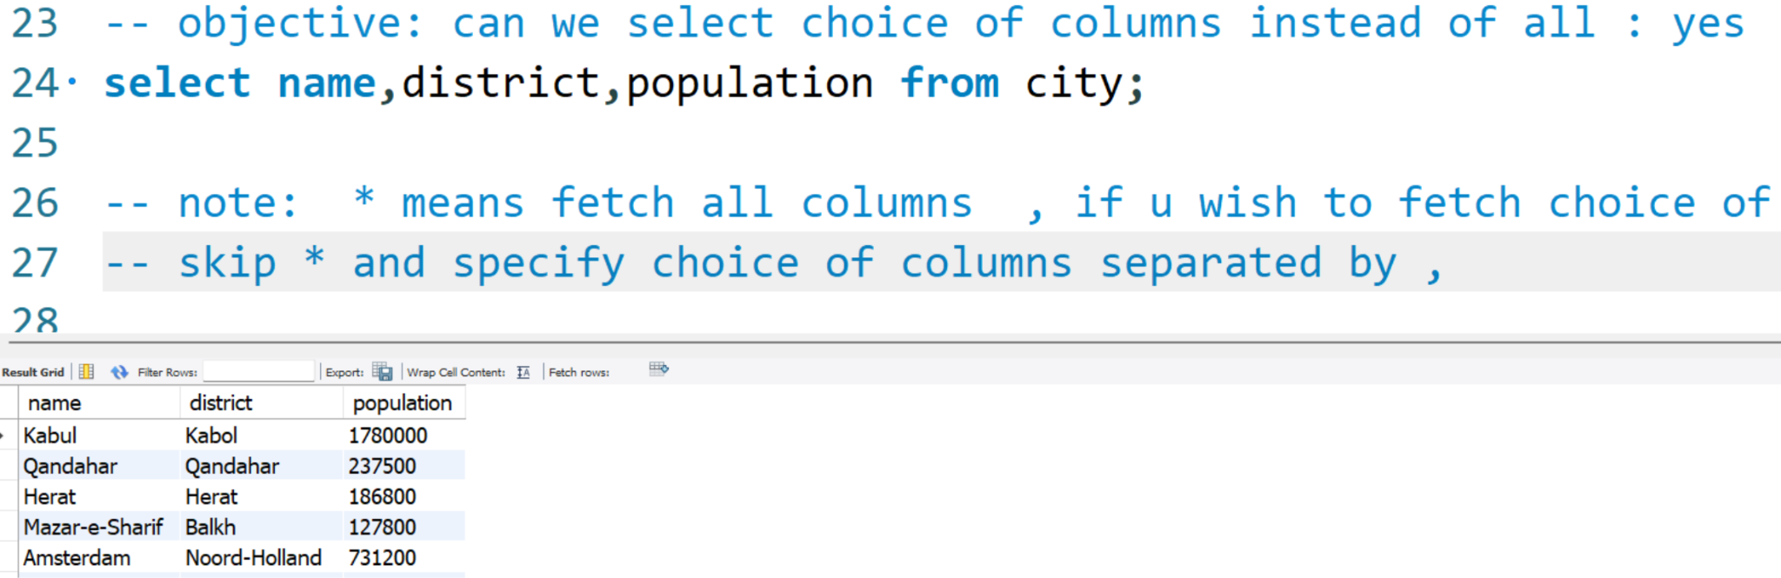

-- can we do math with columns ? YES

select name,district,population , population + 1000 as 'newPop' from city;

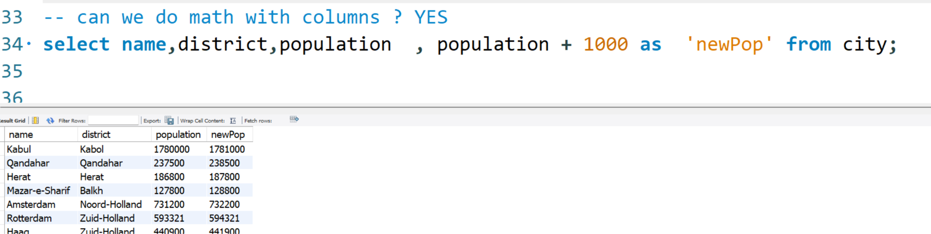

-- can we filter the records ? Yes using 'where'

-- Syntax: select * from <tableName> where <Condition>

-- objective: find the city whose ID matches with '51'

select * from city where id=51;

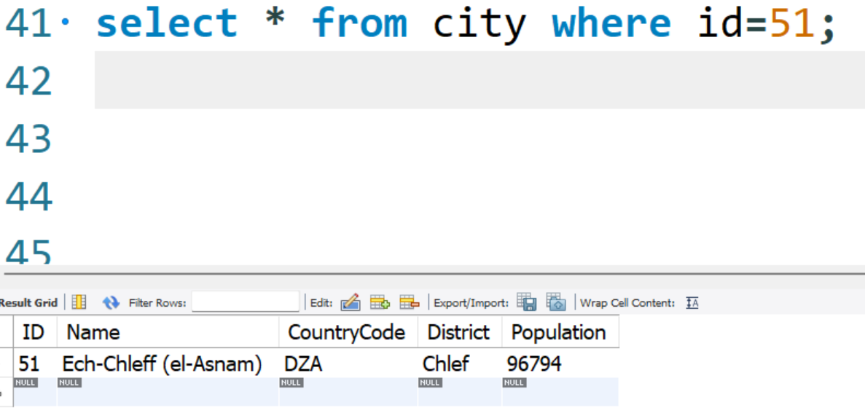

select * from city where population < 800 ;

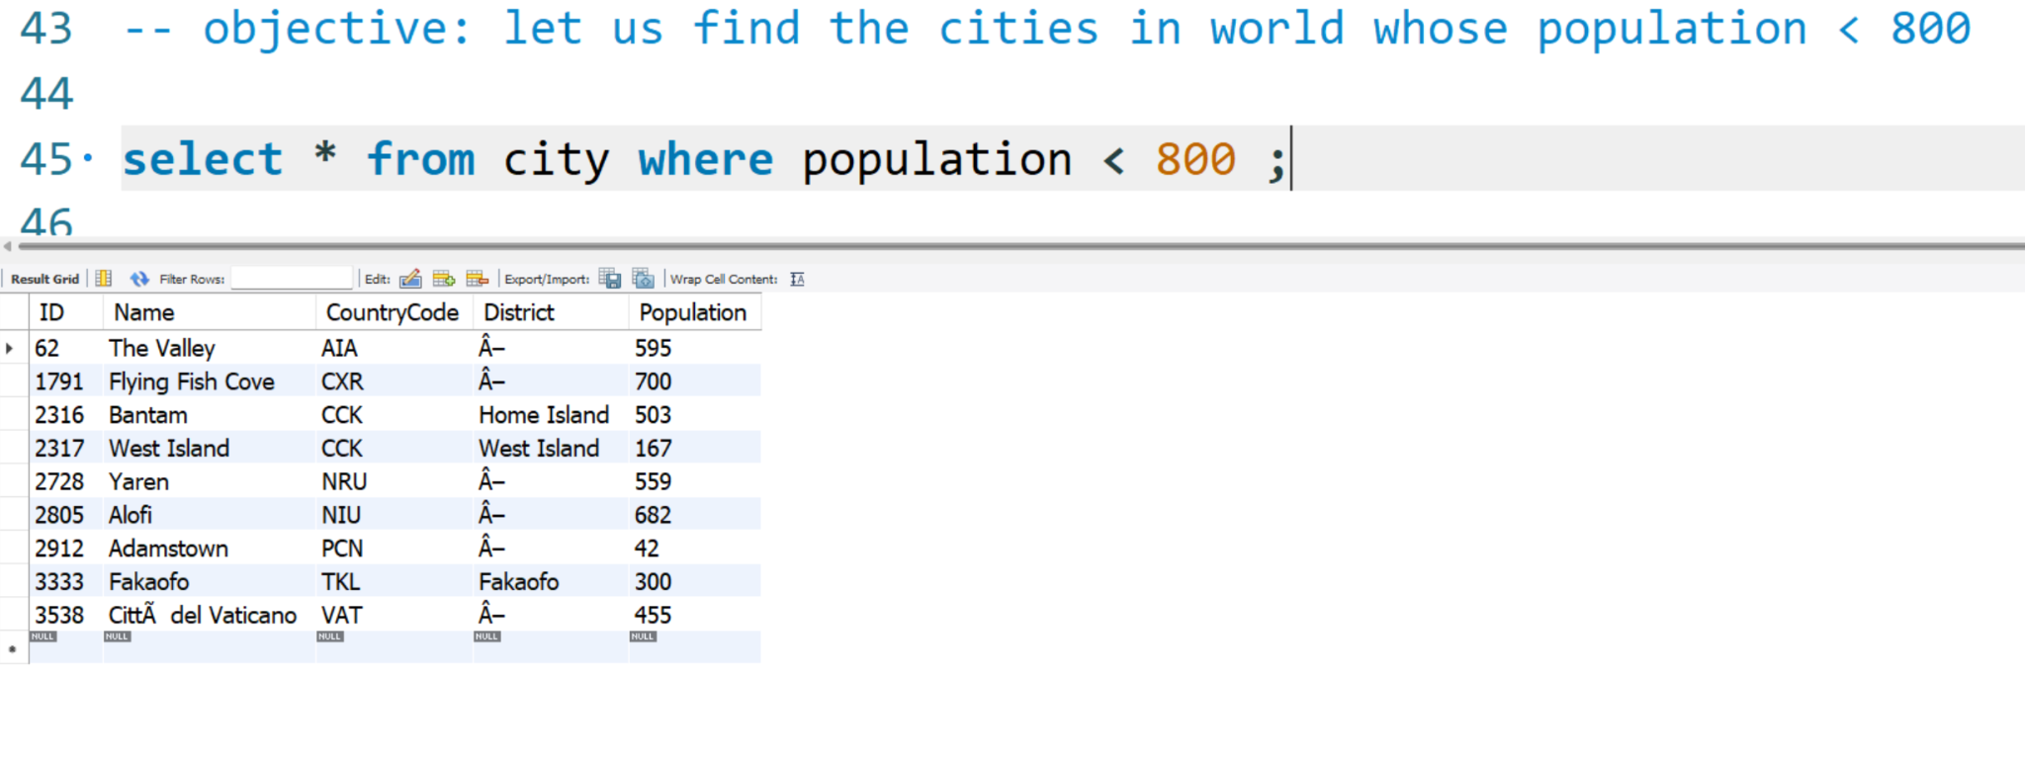

-- objective: you are asked to find INdian Cities !!

-- which column you will target to filter the rows ? countrycode

select * from city where countrycode = 'IND';

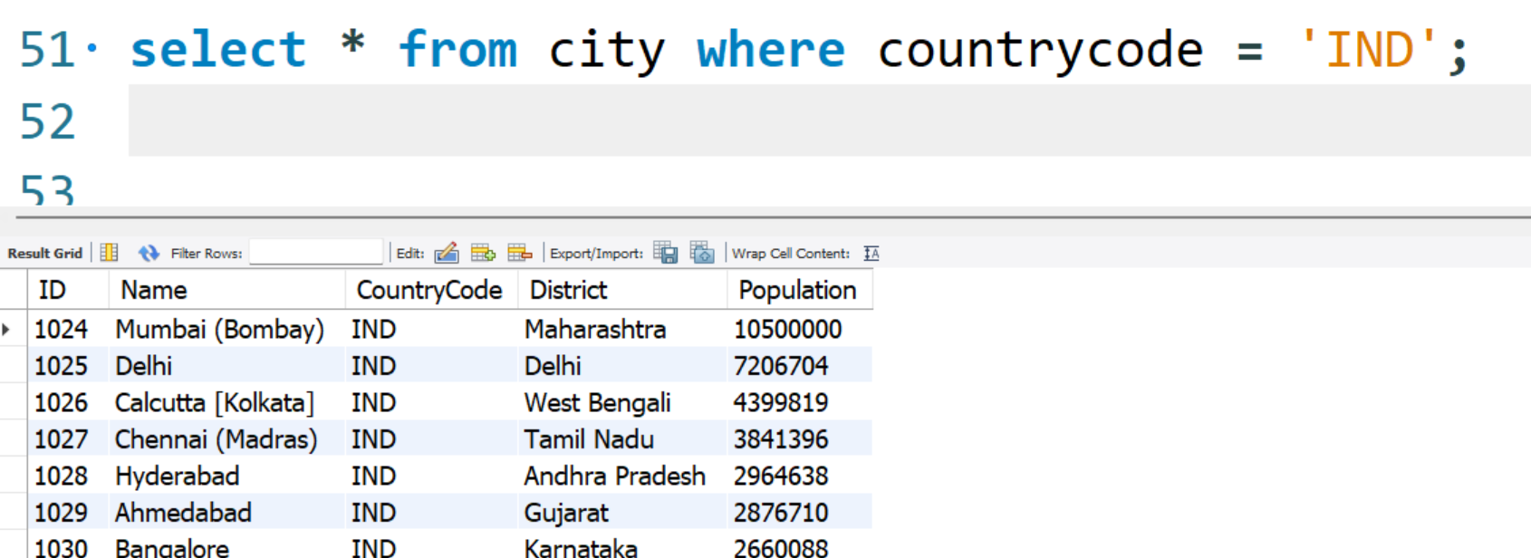

-- Logical Operator AND , OR , NOT

-- using AND

-- OBjective: we are asked to find the cities of District named 'punjab'

select * from city where district='punjab';

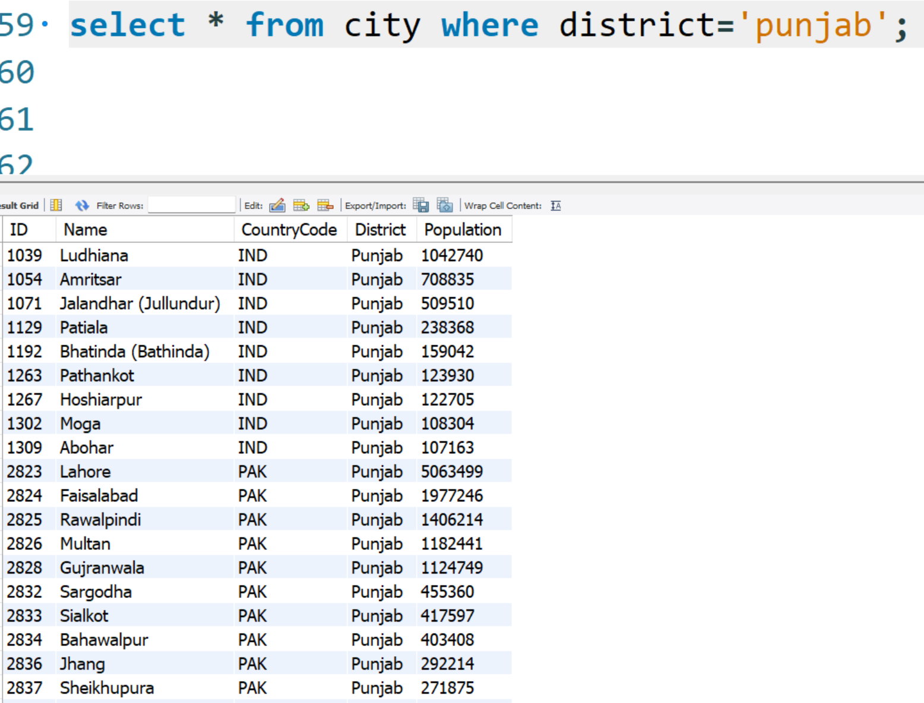

Let us further filter the record using AND

select * from city where district='punjab' and countrycode='IND';

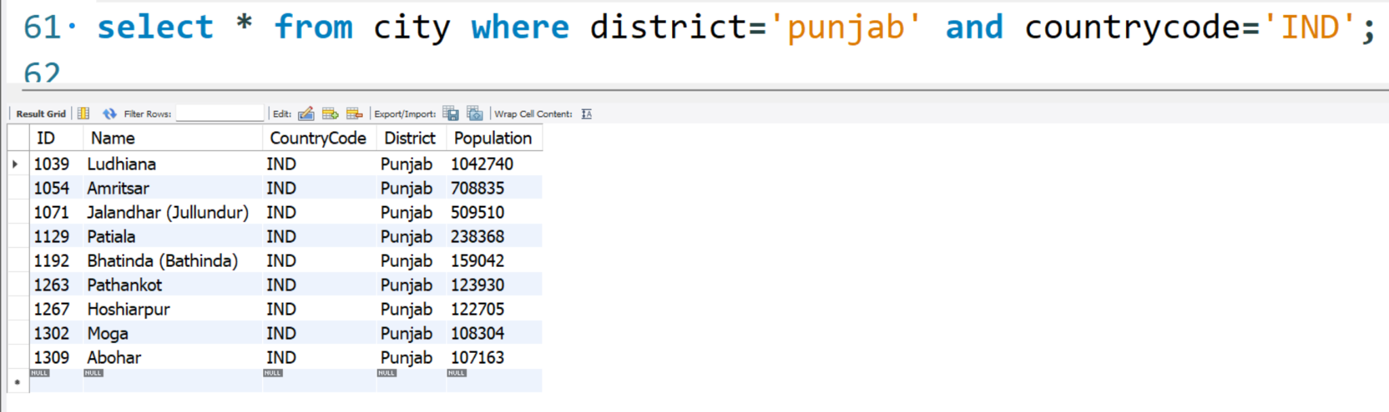

-- you are asked to find the cities whos id is between 2 and 9

select * from city where id>=2 and id<=9;

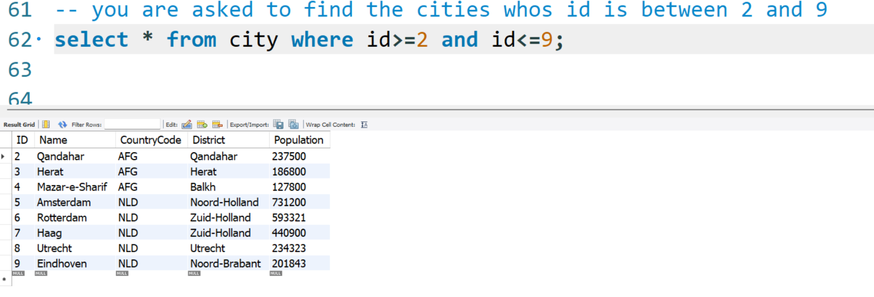

-- using OR

-- Objective: you are asked to find cities whose id matches with either

-- 5, 15, 55

select * from city where id = 5 or id=15 or id=55;

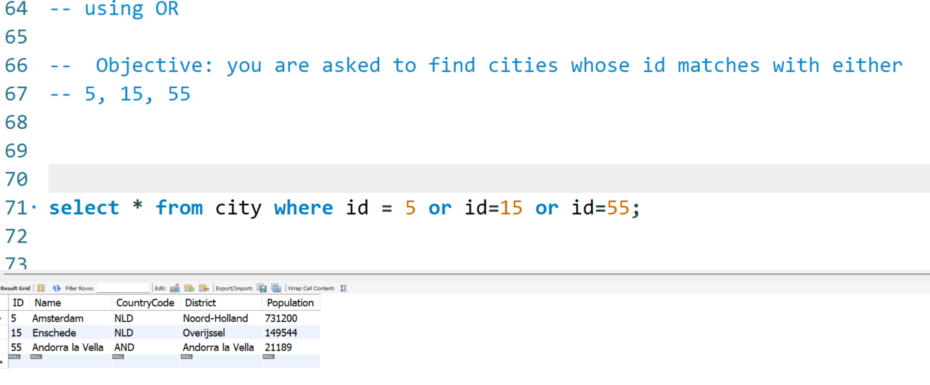

-- Objective: you are asked to find cities of NLD or AUS

select * from city where countrycode = 'nld' or countrycode='aus';

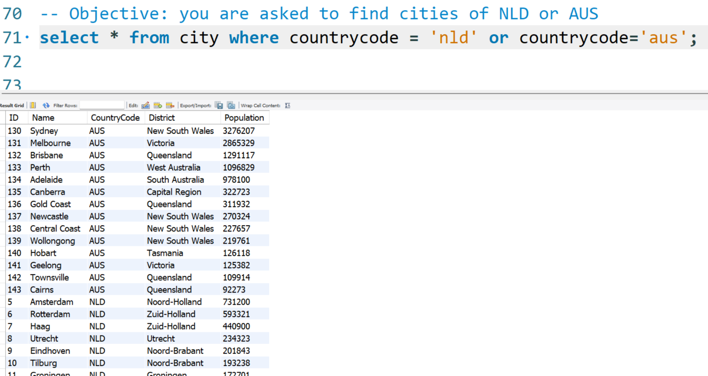

-- using NOT Operator

-- objective: you are asked to find all cities excluding the cities whose id is

-- between 2 and 9

select * from city where not (id>=2 and id<=9);

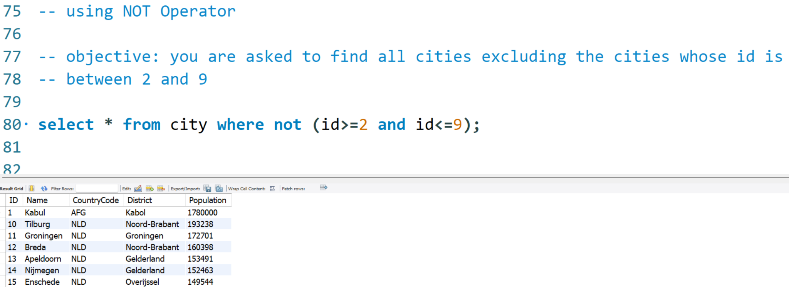

-- Objective: find all cities excluding NLD and AUS cities

select * from city where not ( countrycode = 'nld' or countrycode='aus');

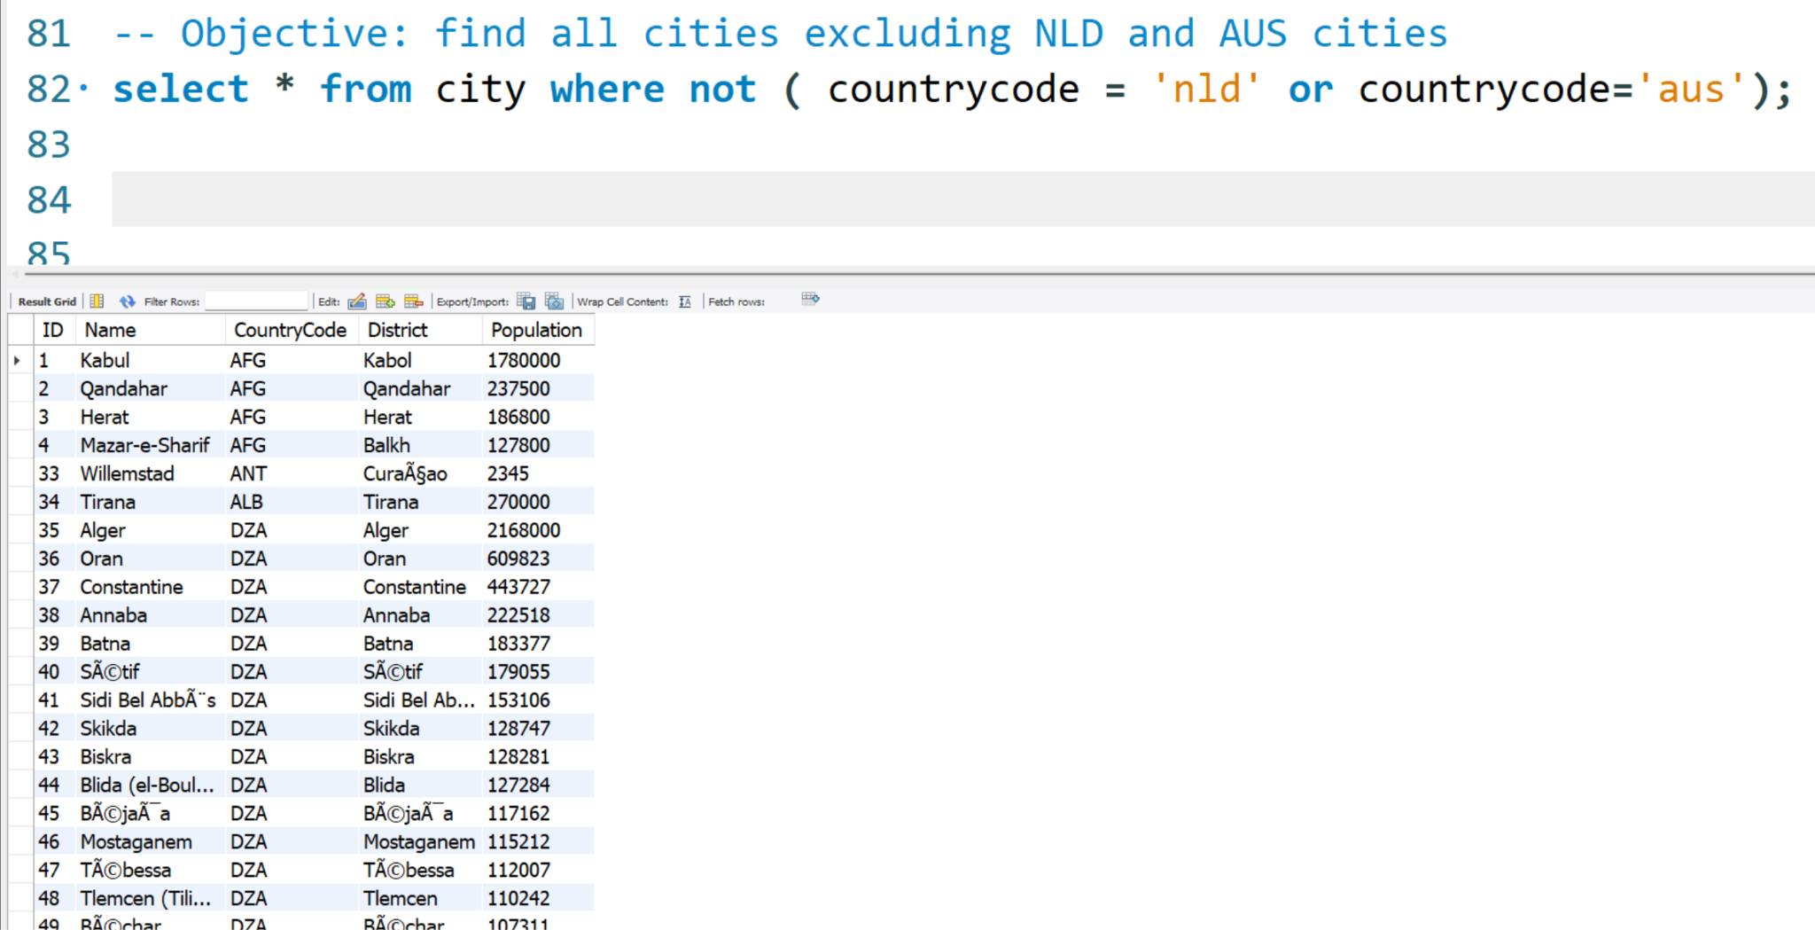

-- SQL Best Practices

-- Range Operator i.e between , not between

-- Range operator is used to capture data in RANGE.

select * from city where id>=2 and id<=9;

select * from city where id between 2 and 9;

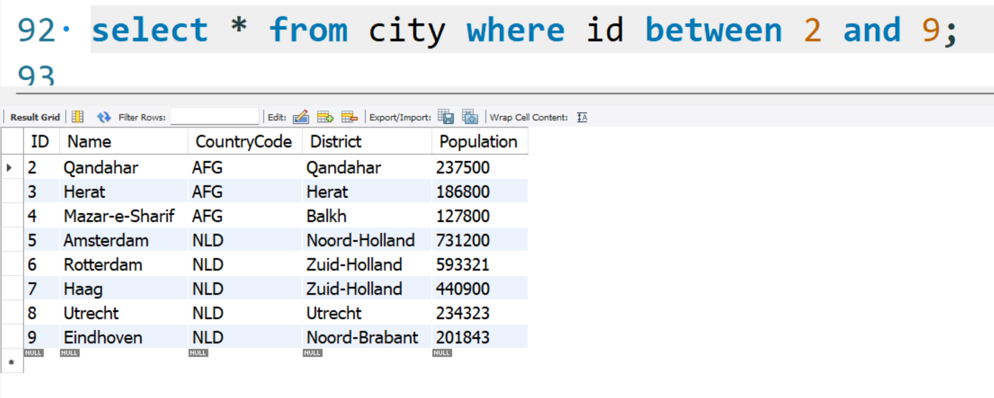

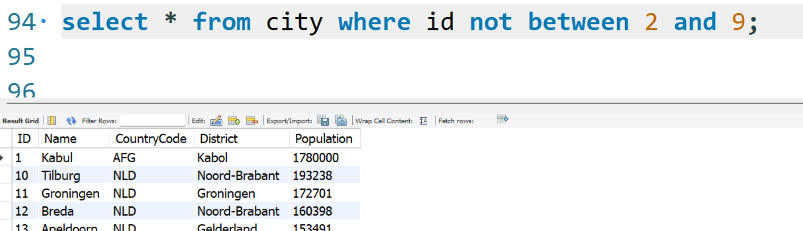

-- in keyword

-- in is used to comapre a single column with Multiple Values.

-- Objective: find the cities whose id is 5, 15 , 55

select * from city where id in (5,15,55);

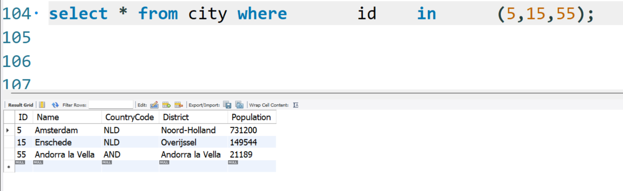

-- combining in and not together

select * from city where countrycode not in ('ind','chn','aus','nld','afg');

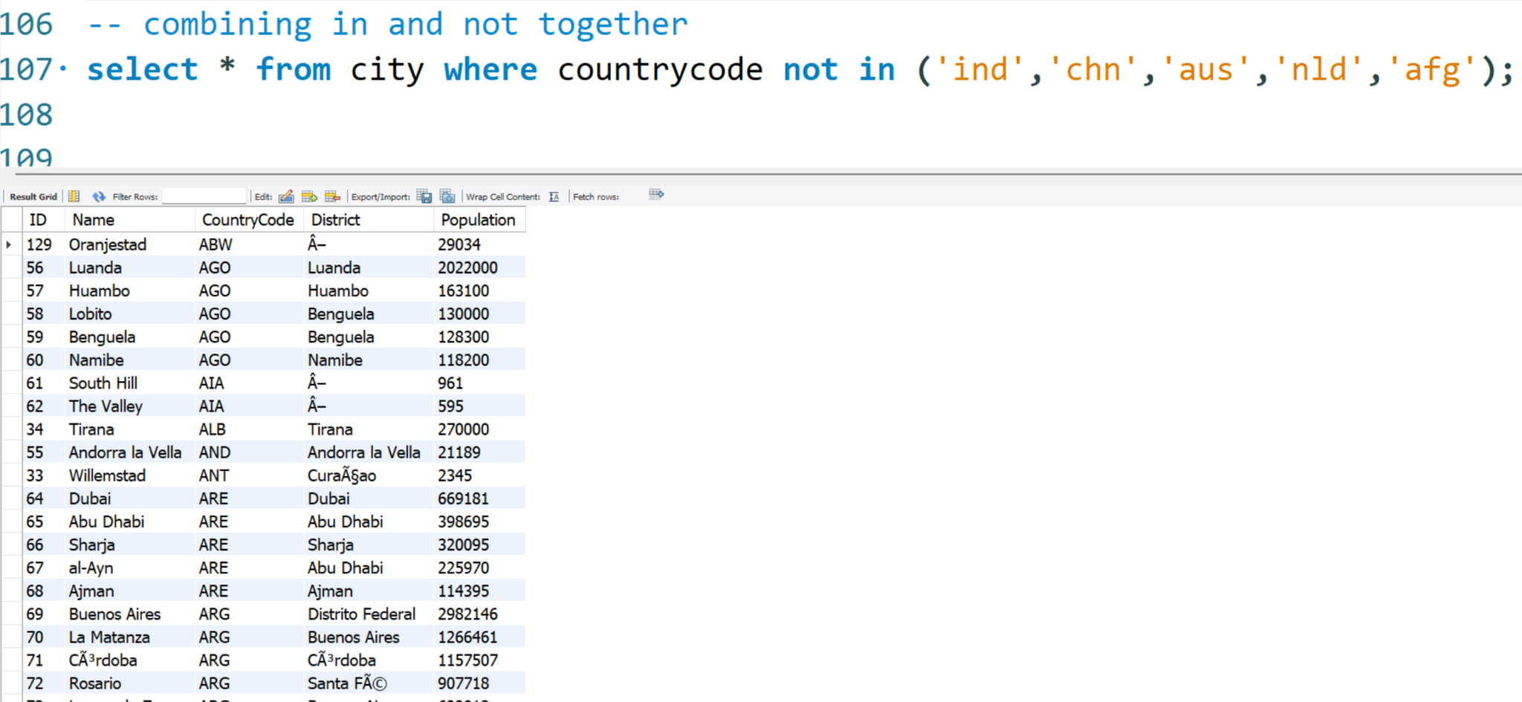

select name,indepyear from country;

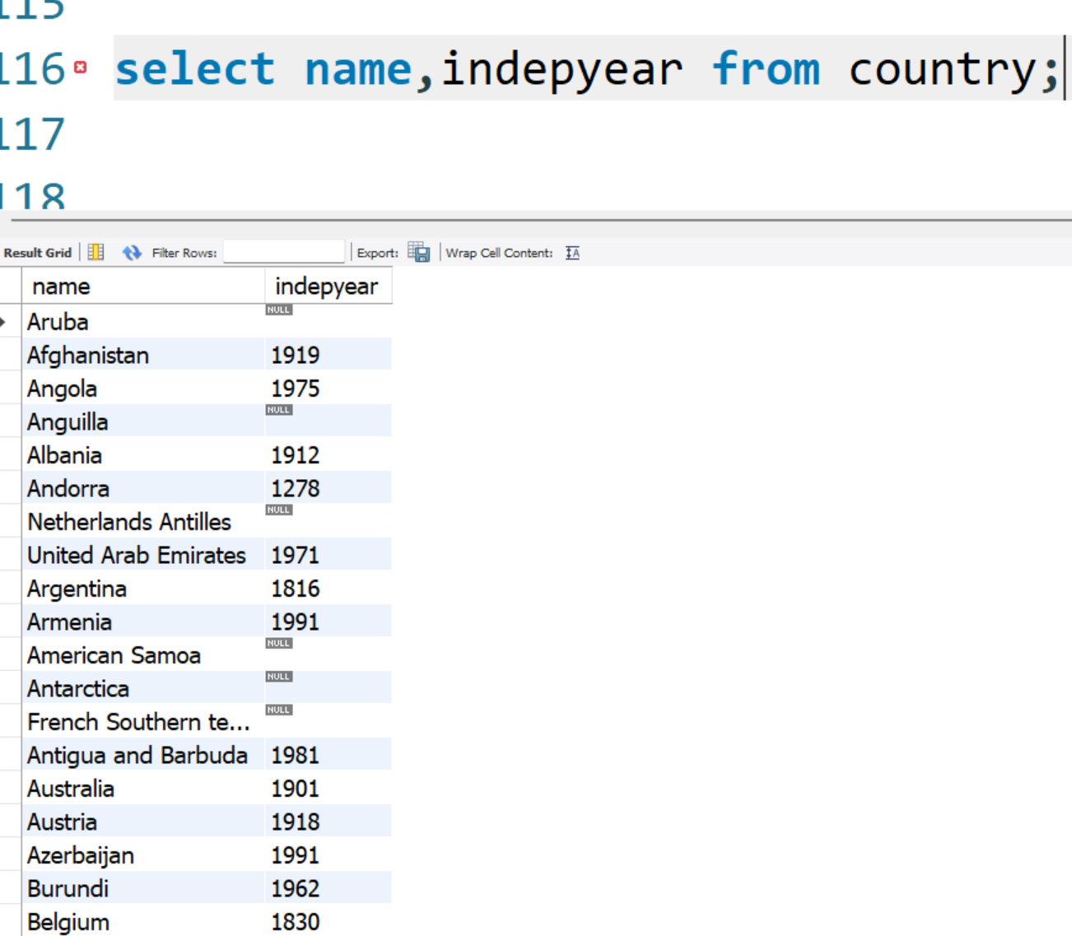

-- Objective: you are asked to fetch only those countries where Indepyear is null

select name,indepyear from country where indepyear is null;

-- note: never use = for comparing a column with null , use is keyword

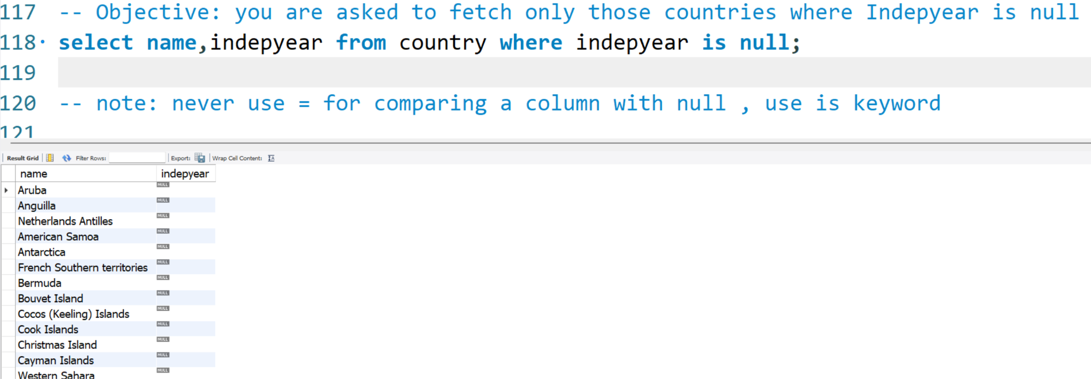

-- replacing null with default values ..

-- here fillNa is ifnull( <column to Scan for Null> , <replacing Value>)

select name , ifnull( indepyear , 'Ouch! Not Available') as 'newIndepYr' from country;

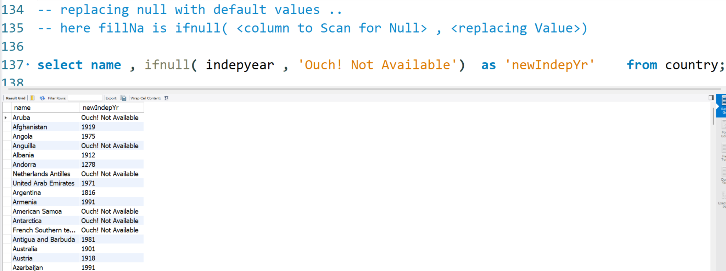

-- you are asked to sort population in descending order for City Table

-- SYntax: select * from <table> order by <column> <order>

select * from city order by population desc;

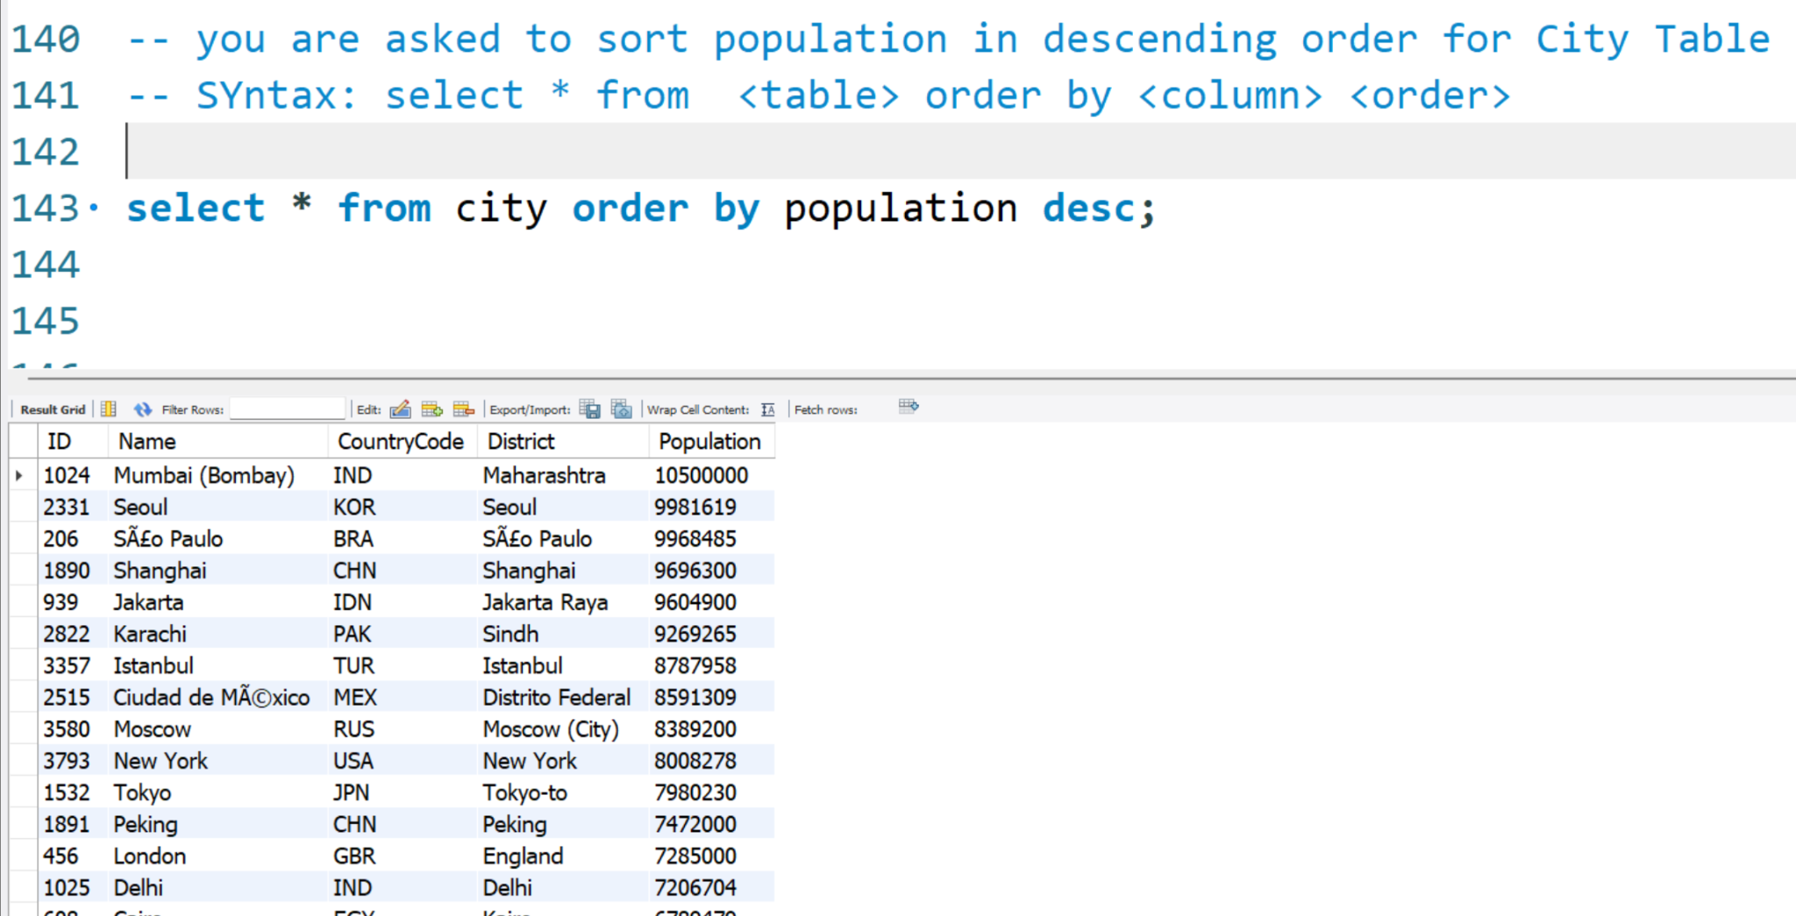

-- you can also limit the output to top N Records using limit keyword

select * from city order by population desc limit 5;

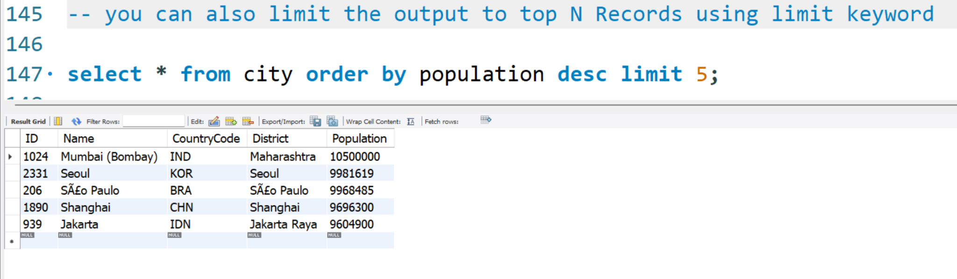

-- objective: find the 7th most populated city of INDIA

-- stage 1

select * from city where countrycode='ind' order by population desc;

-- objective: find the 7th most populated city of INDIA

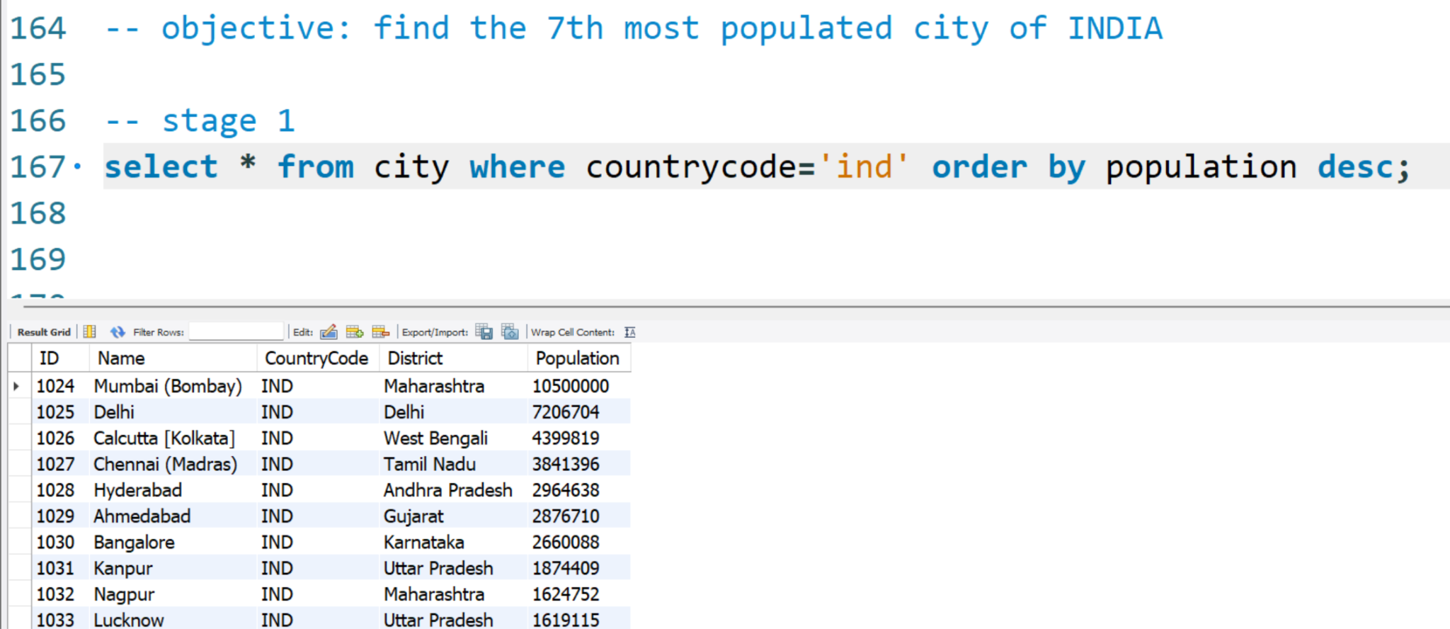

-- stage 2

select * from city where countrycode='ind' order by population desc limit 6,1;

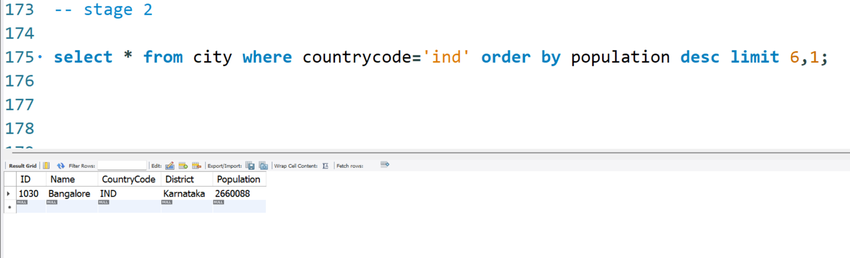

-- Aggregate Functions : aggregate functions help us find statistical facts from Data

select max(population) as 'largest population ' from city;

select min(population) as 'lowest population ' from city;

select sum(population) as 'totalpopulation' from city;

select avg(population) as 'meanpopulation' from city;

select count(population) as 'count ' from city;

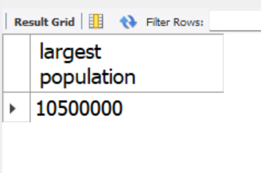

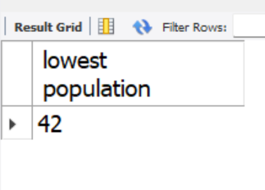

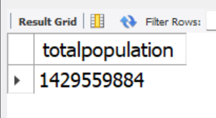

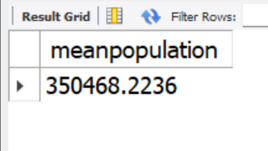

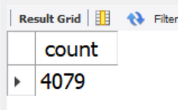

**Note: count() returns Count of Values present in column.**

**(count function excludes nulls when counting)**

select distinct continent from country;

select count(distinct continent) from country;

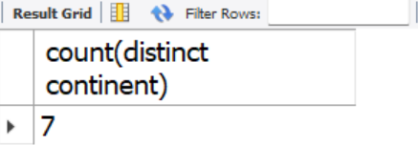

-- Objective: you are asked to Find how many Countries are there in each Continent.

-- SOlution :

-- first we will group the Data by Continent, it will form 7 Groups

-- we will use count() on name column to find the number of values across 7 Groups.

select continent, count(name) as countryCount from country group by continent;

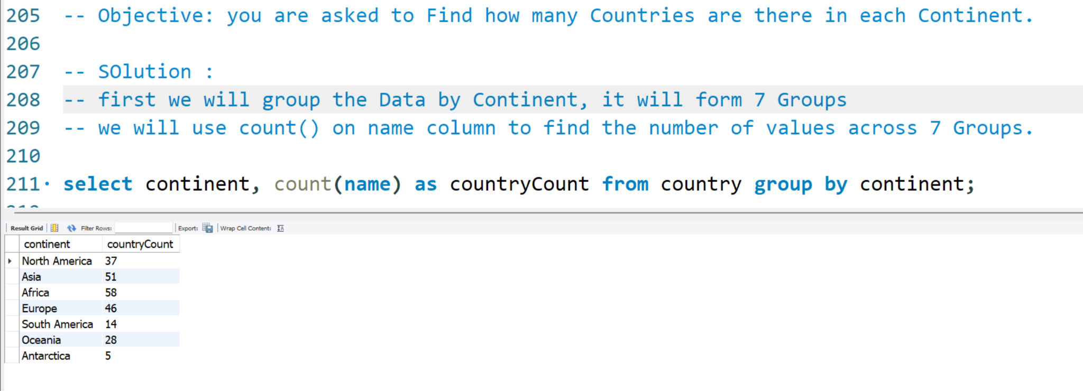

-- filtering in Grouping

select continent, count(name) as countryCount from country group by continent

having count(name) < 50 ;

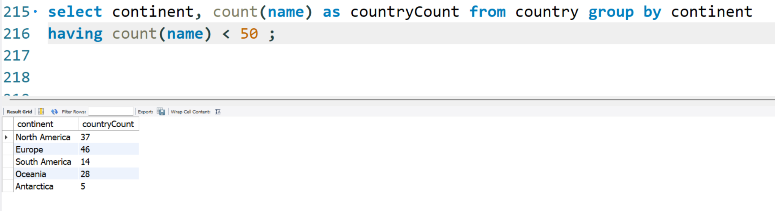

Having: used for filtering rows based on dynamically generated columns such as CountryCount.

Where is used for filtering rows based on Regular Column

Having is used for filterings rows based on aggregated columns.

Eg.

Where population < 1000

Having avg(population) < 1000

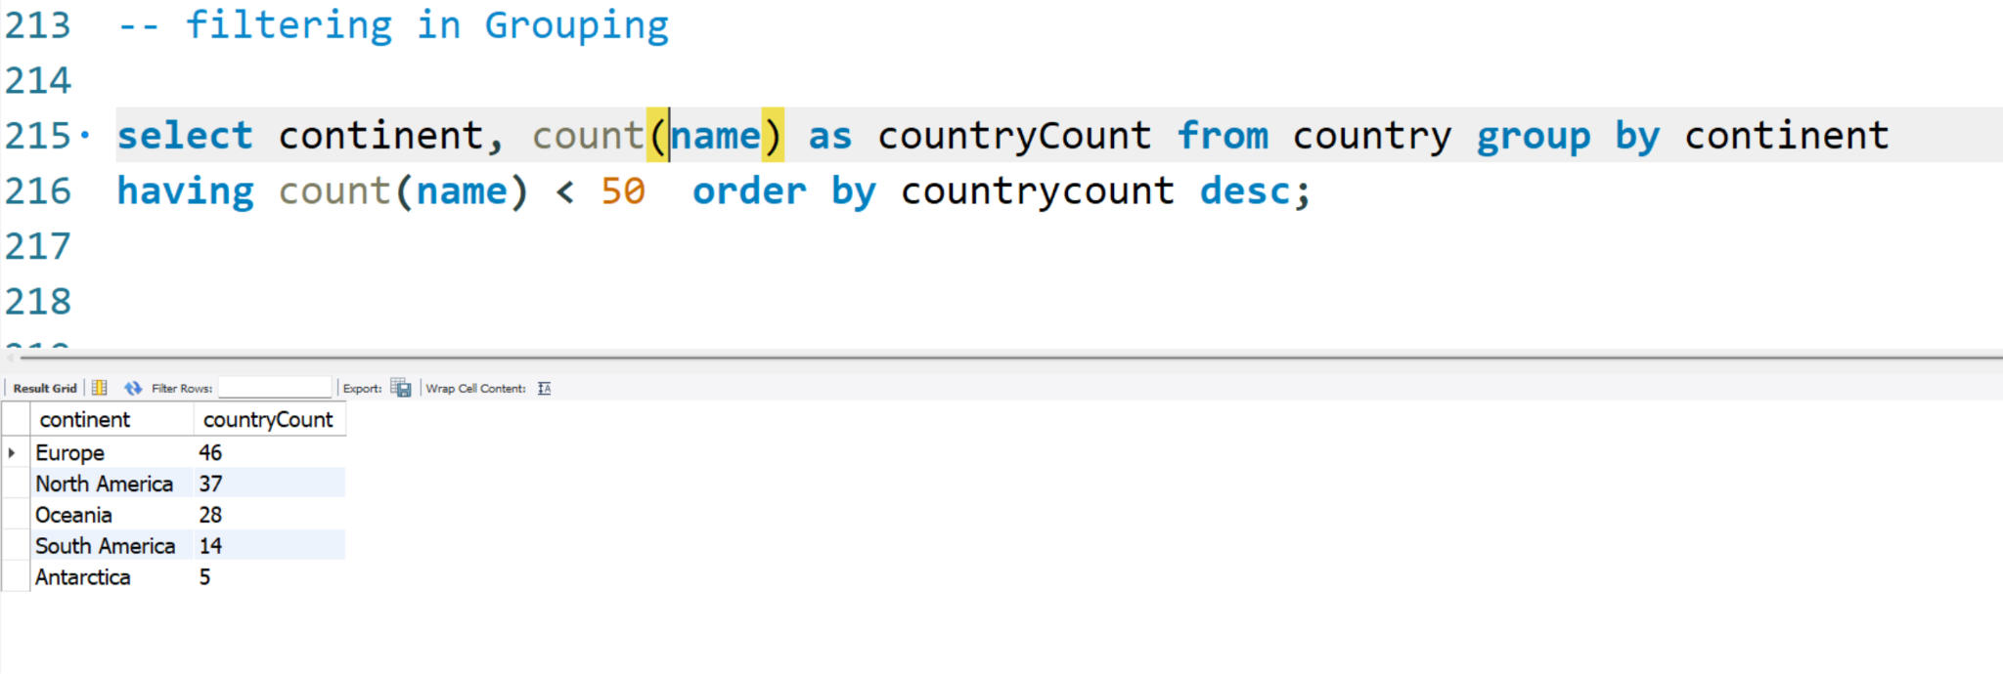

Dataset for Joins LAB :

<https://drive.google.com/file/d/1ODa2ZXd36YgSHVAIzj4shRfUWNAz_NLa/view?usp=sharing>

-- the script restaurant.sql will create a database in our system named 'restaurants_db'

use restaurants_db;

show tables;

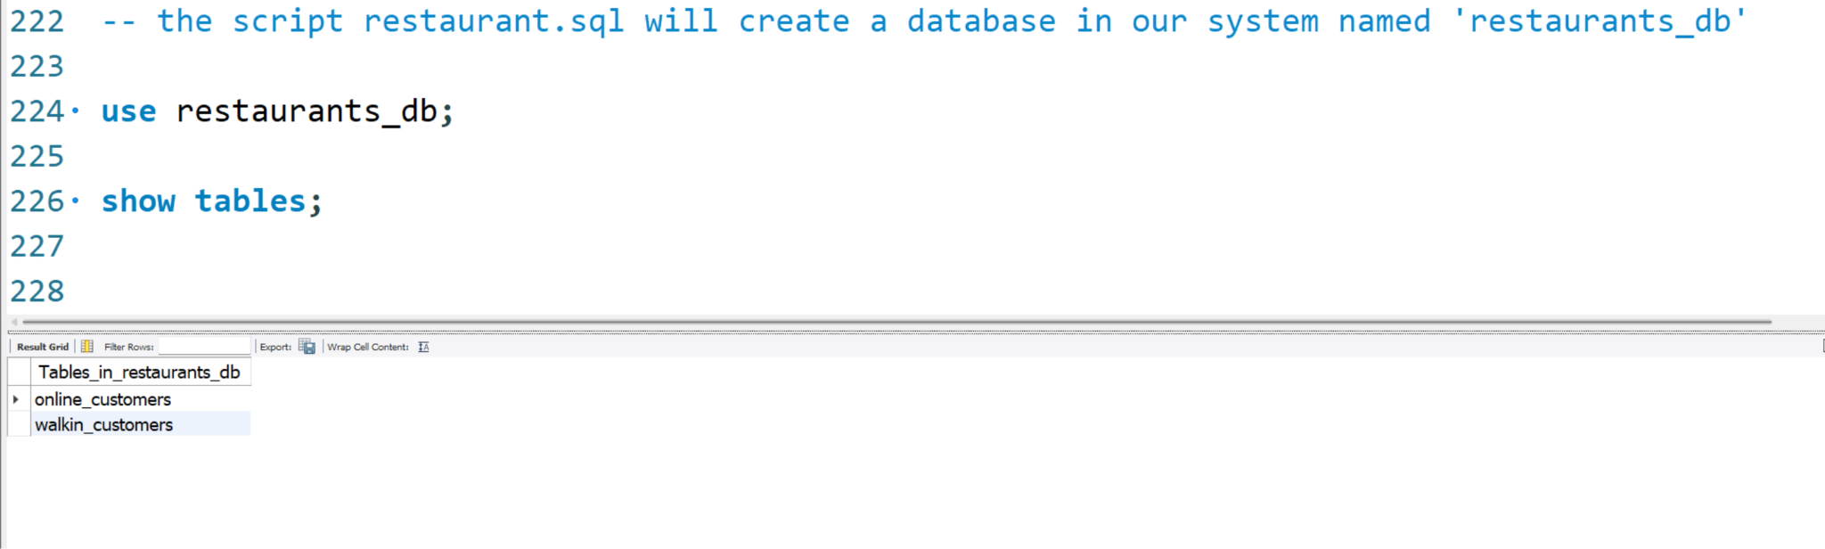

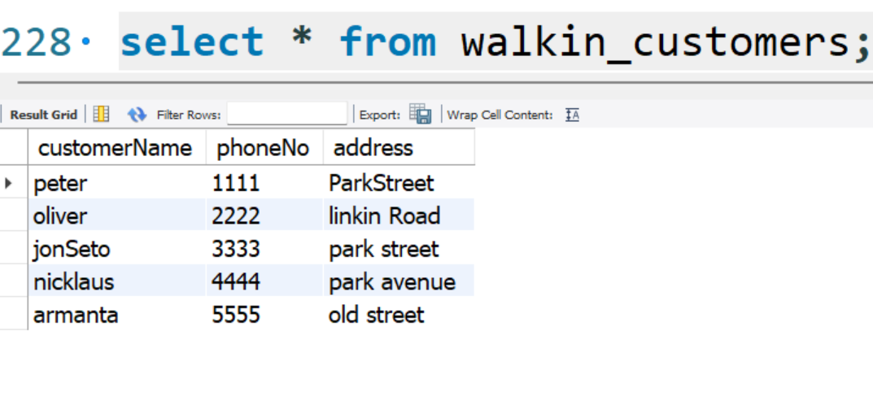

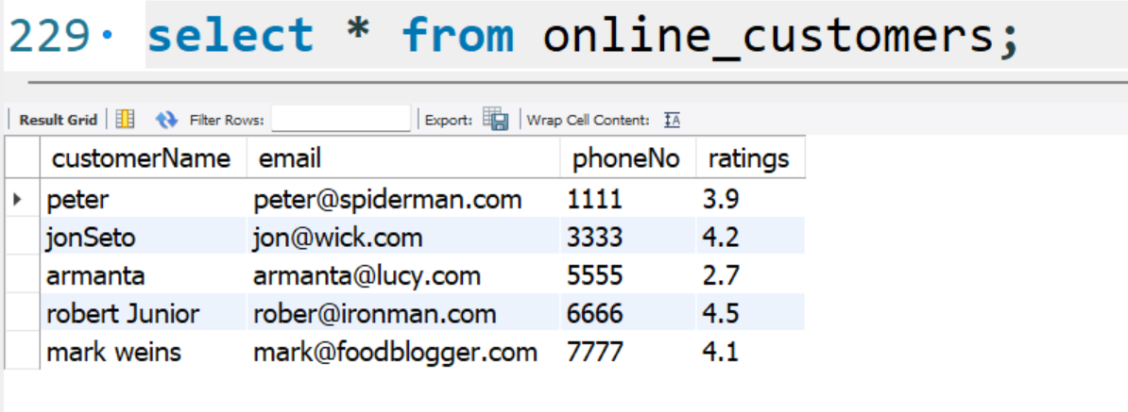

-- Syntax :

-- select <columns> from <Table1> join <Table2>

-- on <table1.commonColumn> = <table2.CommonColumn>

– This is INNER Join : inner join fetches common records from both Tables.

select

wc.customerName as 'walkinCustomer',

oc.customerName as 'onlineCustomer',

wc.phoneno as 'walkinContact',

oc.phoneno as 'onlineContact',

ratings

from walkin_customers wc join online_customers oc

on wc.phoneNo = oc.phoneNo;

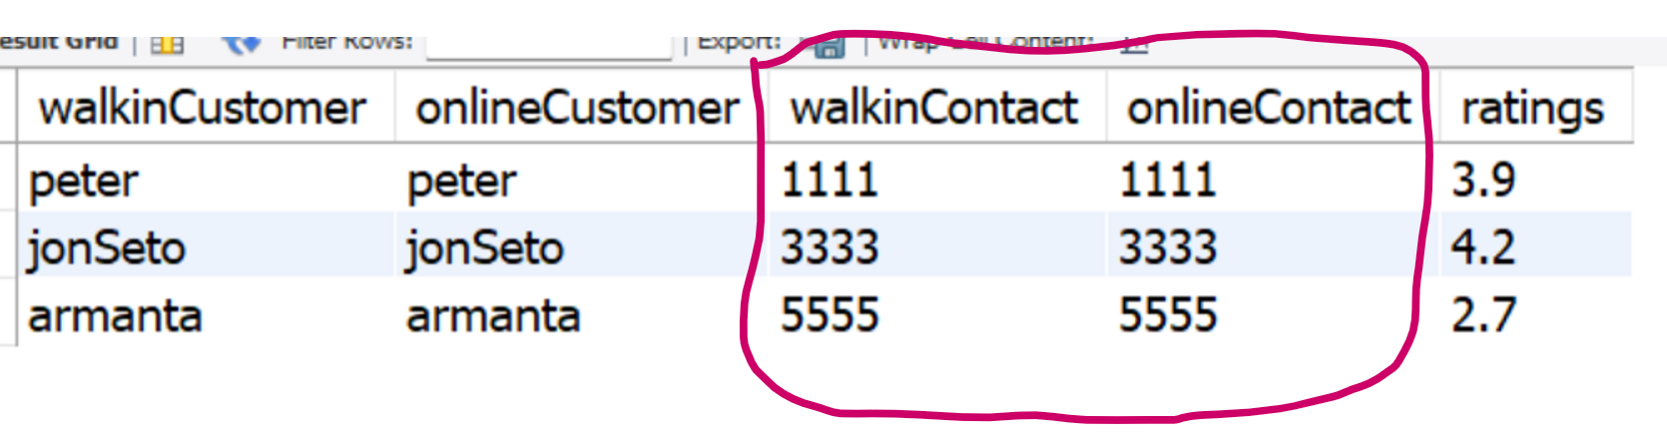

-- Left Join : left join fetches all rows of LEft Table and only matching rows of right table

select

wc.customerName as 'walkinCustomer',

oc.customerName as 'onlineCustomer',

wc.phoneno as 'walkinContact',

oc.phoneno as 'onlineContact',

ratings

from walkin_customers wc left join online_customers oc

on wc.phoneNo = oc.phoneNo;

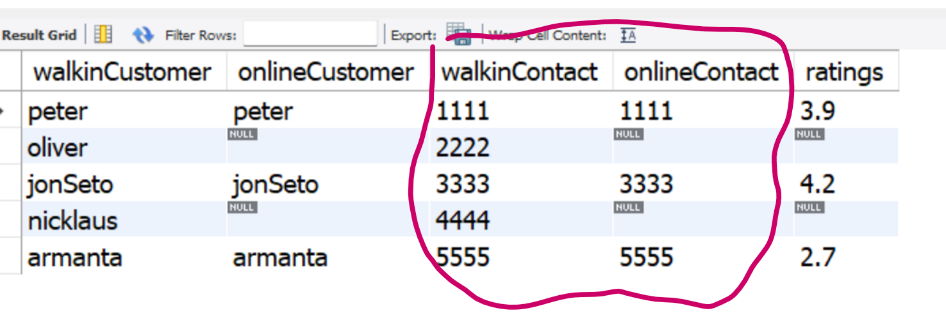

-- Right Join : all rows of Right Table and only matching rows of left table.

select

wc.customerName as 'walkinCustomer',

oc.customerName as 'onlineCustomer',

wc.phoneno as 'walkinContact',

oc.phoneno as 'onlineContact',

ratings

from walkin_customers wc right join online_customers oc

on wc.phoneNo = oc.phoneNo;

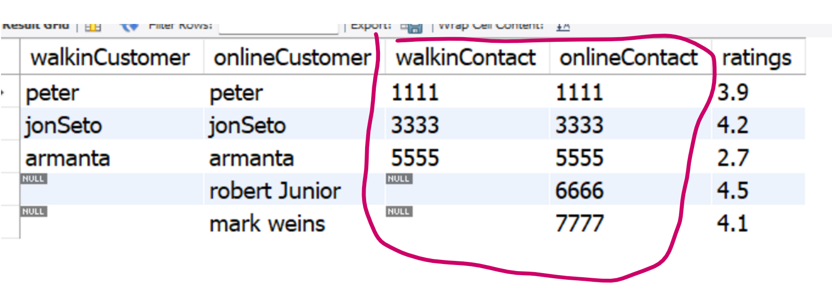

– ALL Labs

-- we can start the labs now

-- Please note : the script that we just RAN createad a Database in our System

-- named : world

show databases; -- press ctrl+enter to execute

use world;

-- let us see what all tables it has (world database)

show tables;

select * from countrylanguage;

-- objective: display table in Sql

-- syntax: select * from <tableName>

select * from city;

-- objective: can we select choice of columns instead of all : yes

select name,district,population from city;

-- note: * means fetch all columns , if u wish to fetch choice of columns,

-- skip * and specify choice of columns separated by ,

-- can we do math with columns ? YES

select name,district,population , population + 1000 as 'newPop' from city;

-- can we filter the records ? Yes using 'where'

-- Syntax: select * from <tableName> where <Condition>

-- objective: find the city whose ID matches with '51'

select * from city where id=51;

-- objective: let us find the cities in world whose population < 800

select * from city where population < 800 ;

select * from city;

-- objective: you are asked to find INdian Cities !!

-- which column you will target to filter the rows ? countrycode

select * from city where countrycode = 'IND';

-- Logical Operator AND , OR , NOT

-- using AND

-- OBjective: we are asked to find the cities of District named 'punjab'

select * from city where district='punjab' and countrycode='IND';

-- you are asked to find the cities whos id is between 2 and 9

select * from city where id>=2 and id<=9;

-- using OR

-- Objective: you are asked to find cities whose id matches with either

-- 5, 15, 55

select * from city where id = 5 or id=15 or id=55;

-- Objective: you are asked to find cities of NLD or AUS

select * from city where countrycode = 'nld' or countrycode='aus';

-- using NOT Operator

-- objective: you are asked to find all cities excluding the cities whose id is

-- between 2 and 9

select * from city where not (id>=2 and id<=9);

-- Objective: find all cities excluding NLD and AUS cities

select * from city where not ( countrycode = 'nld' or countrycode='aus');

-- SQL Best Practices

-- Range Operator i.e between , not between

-- Range operator is used to capture data in RANGE.

select * from city where id>=2 and id<=9;

select * from city where id between 2 and 9;

select * from city where id not between 2 and 9;

-- in keyword

-- in is used to comapre a single column with Multiple Values.

-- Objective: find the cities whose id is 5, 15 , 55

select * from city where id in (5,15,55);

-- combining in and not together

select * from city where countrycode not in ('ind','chn','aus','nld','afg');

-- Handling Nulls

select * from country;

select name,indepyear from country;

-- Objective: you are asked to fetch only those countries where Indepyear is null

select name,indepyear from country where indepyear is null;

-- note: never use = for comparing a column with null , use is keyword

select name,indepyear from country where indepyear is null;

-- syntax: select * from <table> where <column>Z is null

select name , indepyear from country where indepyear is null;

-- replacing null with default values ..

-- here fillNa is ifnull( <column to Scan for Null> , <replacing Value>)

select name , ifnull( indepyear , 'Ouch! Not Available') as 'newIndepYr' from country;

-- you are asked to sort population in descending order for City Table

-- SYntax: select * from <table> order by <column> <order>

select * from city order by population desc;

-- you can also limit the output to top N Records using limit keyword

select * from city order by population desc limit 5;

-- limit with offset;

select * from city limit 9 , 5;

-- give me 15th row to next five rows

-- objective: find the 7th most populated city of INDIA

-- stage 1

select * from city where countrycode='ind' order by population desc;

-- stage 2

select * from city where countrycode='ind' order by population desc limit 6,1;

-- Aggregate Functions : aggregate functions help us find statistical facts from Data

select max(population) as 'largest population ' from city;

select min(population) as 'lowest population ' from city;

select sum(population) as 'totalpopulation' from city;

select avg(population) as 'meanpopulation' from city;

select count(population) as 'count ' from city;

-- Grouping

select distinct continent from country;

select count(distinct continent) from country;

select name,continent from country;

-- Objective: you are asked to Find how many Countries are there in each Continent.

-- SOlution :

-- first we will group the Data by Continent, it will form 7 Groups

-- we will use count() on name column to find the number of values across 7 Groups.

select continent, count(name) as countryCount from country group by continent;

-- filtering in Grouping

select continent, count(name) as countryCount from country group by continent

having count(name) < 50 order by countrycount desc;

-- the script restaurant.sql will create a database in our system named 'restaurants_db'

use restaurants_db;

show tables;

select * from walkin_customers;

select * from online_customers;

-- let us use join to find details from Both Table

-- Syntax :

-- select <columns> from <Table1> join <Table2>

-- on <table1.commonColumn> = <table2.CommonColumn>

select

wc.customerName as 'walkinCustomer',

oc.customerName as 'onlineCustomer',

wc.phoneno as 'walkinContact',

oc.phoneno as 'onlineContact',

ratings

from walkin_customers wc join online_customers oc

on wc.phoneNo = oc.phoneNo;

-- Left Join : left join fetches all rows of LEft Table and only matching rows of right table

select

wc.customerName as 'walkinCustomer',

oc.customerName as 'onlineCustomer',

wc.phoneno as 'walkinContact',

oc.phoneno as 'onlineContact',

ratings

from walkin_customers wc left join online_customers oc

on wc.phoneNo = oc.phoneNo;

-- Right Join : all rows of Right Table and only matching rows of left table.

select

wc.customerName as 'walkinCustomer',

oc.customerName as 'onlineCustomer',

wc.phoneno as 'walkinContact',

oc.phoneno as 'onlineContact',

ratings

from walkin_customers wc right join online_customers oc

on wc.phoneNo = oc.phoneNo;